WELCOME TO THE   
COGNITIVE SCIENCE  
INTRODUCTION WEEK 2019

# Dear Cognitive Science Students,

As a start, we would like to congratulate you on having been accepted into the international bachelor program of Cognitive Science! WAUW! You are going to spend the next three years of your life in the “hyggelig” student atmosphere and inspiring educational environment of Aarhus University - Hurraaay!  
So what happens now? Well… We would like to invite you to participate in an introduction week (from the 26th of August to the 30th of August), which will help you to get to know your future teachers and fellow students. We promise you this will be an adventure of a week brimming with fun activities, insights into the student-life at “CogSci” and inspiring lectures and experiments to excite your neurons.

On Monday the 26th of August at 9:00, you will be divided into smaller groups, which you will hear more about later. You and your group will eat breakfast with some of the tutors before going to the University – YAY! And hey, if you are not able to find the right address or… you miss the bus…well, don’t fret, because on the next page you will see the we’ve created a list of phone numbers for all the tutors.

Actually, this pamphlet is brimming with information that will serve you well, so have a good look and we’ll be seeing you in no time!

Sincerely,  
Your Tutors

#### What does a brain do when it sees a friend? It sends a brain wave



PRACTICAL INFORMATION

Where to go? On the first day, you will meet at your tutors’ homes around the city and you’ll get sent information over mail and Facebook about this, as we approach the Introduction week. The other days have different locations, but the building and room number are all specified in the program below.

During the introduction days, you will discover many places within the University Campus. We will show you where your teachers’ offices are located, how to find the university library and where to go to get your daily shot of caffeine. But to please your inner adventurer we will give you these tools to guide you.

You might for example find this link to a map of the campus handy.

Scan the QR code or visit the following link:

### <http://www.au.dk/en/about/organisation/find-au/buildingmap/>



You can also download the AU Find app for Apple or Android.   
Scan the QR code or visit the following link:

### <http://www.au.dk/en/about/organisation/find-au/aufind/>

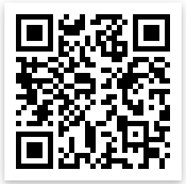

You should also join the Facebook group for Cognitive Science students 2019. Here we will be posting updates regarding the introduction program, e.g. where your tutors live. So, join the group, ask questions and be in the loop as we’ll update you continuously! Scan the QR code or visit the following link:

### <https://www.facebook.com/groups/333544764028140/>

# Coordinating Tutor:

Sebastian Scott Engen

E-mail: [snuggle.hogwarts@gmail.com](mailto:snuggle.hogwarts@gmail.com), Phone: +45 61737227

# Tutors:

Nina Mathilde Dyrberg (+45 20140487), Sara Møller Østergaard (+45 29897215), Anders Haagerup (+45 20168689), Kiri Koppelgaard (+45 23989841), Lena Hansen (+49 15223386830), Jacob Aarup Dalsgaard (+45 42199551), Astrid Sletten Rybner (+45 60863923), Sofie Smith Jacobsen (+45 25704439), Frida Hæstrup (+45 27891817), Emil Trenckner Jessen (+45 23442044), Stephanie Jensen (+45 26848014), Lars Kjartan Bacher Svendsen (+45 60686046), Karoline Engstrøm Poulsen (+45 23 70 77 44), Malte Højmark-Bertelsen (+45 22560120), Melina Nielsen (+45 22589796), Sofie Rødkjær Blendstrup (+45 20654131) & Orla (+44 7576916511)

, Sara, Kiri, Sofie Rødkjær, Melina, Malte, Karoline, Signe, Lars,, Emil, Frida, Sofie Jacobsen, Astrid, Jacob, Lena, Orla, Anders & Stephanie.

# PROGRAM FOR THE INTRODUCTION DAYS

Below you will see the program for the introduction week for Cognitive Science. Make room in your calendar, because you do not want to miss this week! It is not obligatory to participate in any of the activities, although we HIGHLY recommended it! It is the best way to meet your fellow students and it will give you a much better understanding of what Cognitive Science is about.

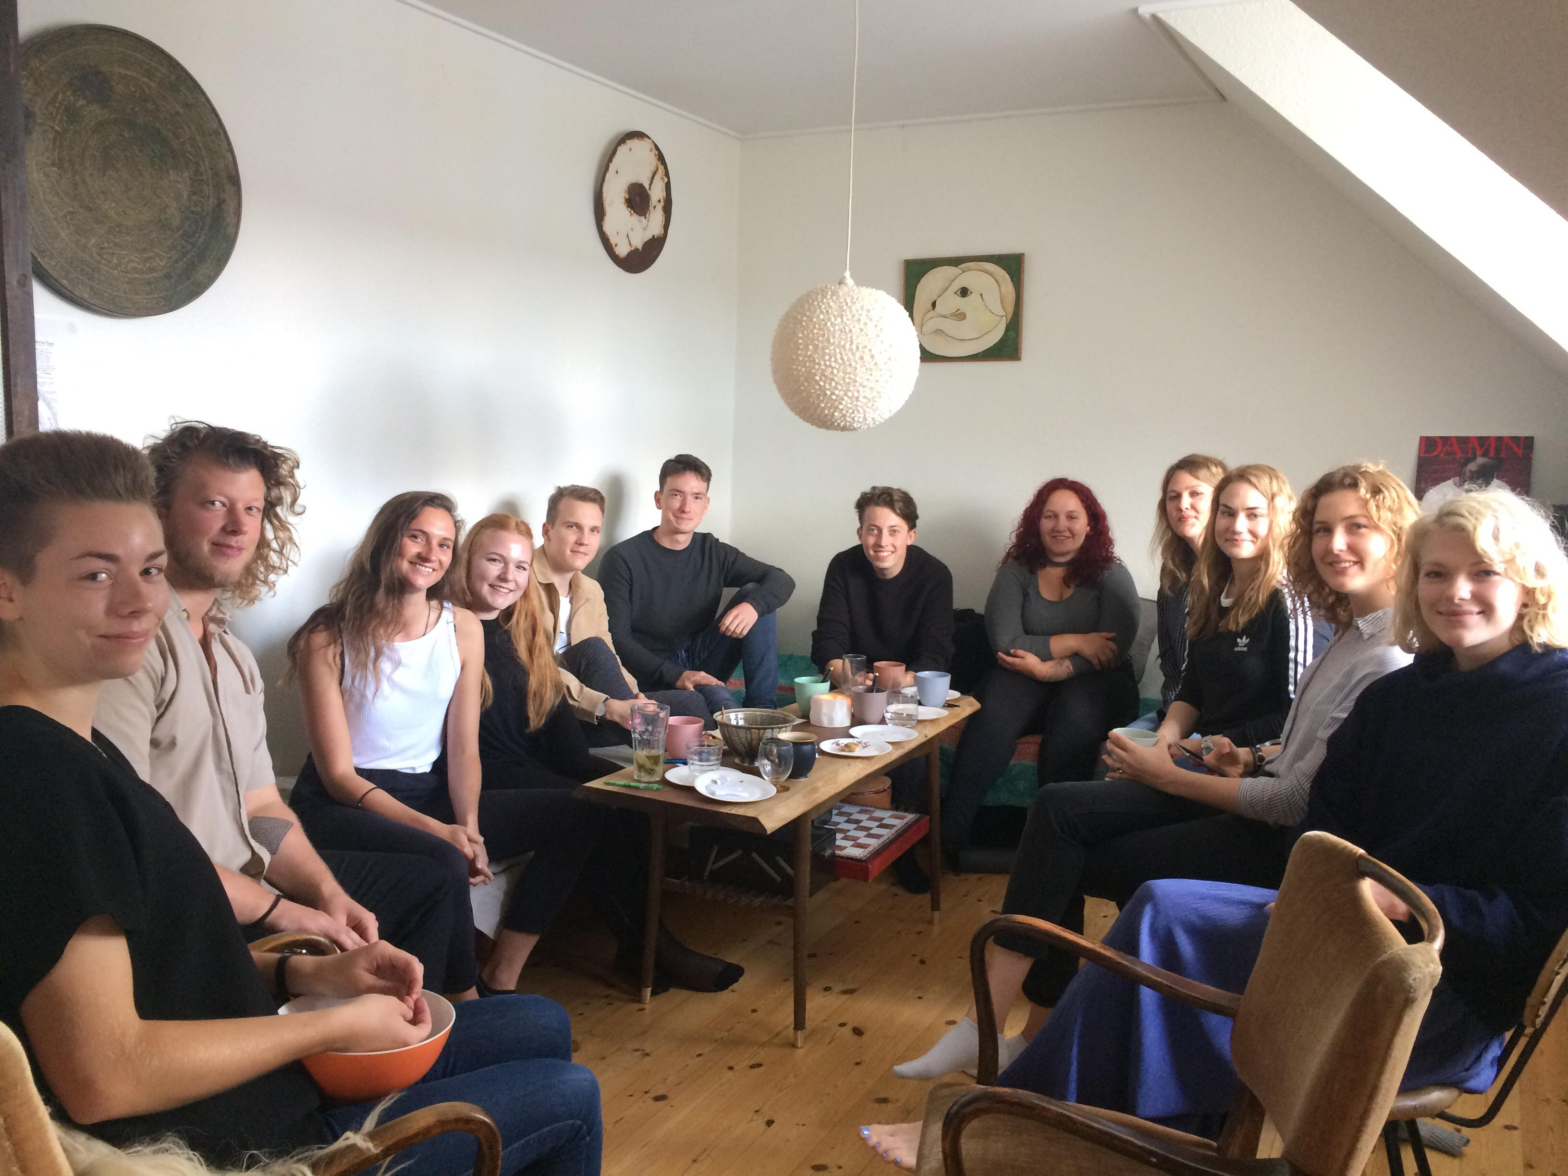

### Former new students having breakfast with their tutors Monday morning

Monday the 25th of August (Outside Building 1481)

**On your own:** We suggest that you look up bike-rentals in Aarhus (You don’t necessarily need a bike, but we do think it’s a good idea to swap the bus for a bike, as you’ll both save money and be able to ride with the rest of us, when we go around the town throughout the introduction week)

Monday the 26th of August (Building 1441, Room 113)

09:00-11:00 Breakfast with the tutors

11:00-11:30 Introduction: What is Cognitive Science?

11:30-12:30 Name games

12:30-13:30 Lunch

13:30-14:00 Introduction to IT

14:00-16:00 Fun at the University Park

16:00-22:00 Friday Bar at Broca’s Bodega

Tuesday the 27th of August (Building 1441, Room 113)

*08:30-08:45 Breakfast w/ bread and coffee*

08.45-09.00 Presentation of the day

09.00-09.30 Visit from ARTS karriere

09:30-09:45 Visit from Studenterhus Aarhus

10:00-10:30 Visit at the Nobel Library

10:30-11:00 TBA

11:00-11:30 Lecture with Fabio Trecca

11:30-12:30 Lunch

12:30-14:45 Study group activities w/ Mikkel Wallentin

14:45-15:00 Presentation by International Students

15:00-16:30 TBA

16:30-21:00 BBQ & play in Riis Skov

Wednesday the 28th of August (Building 1485, Room 123)

*08:30-08:45 Breakfast w/ bread and coffee*

*08:45-09.00* Presentation of the day

09:00-11:00 Introduction To Game Theory

11:00-11:30 Pub Crawl Talk

11:30-12:45 Excursion to BilligBilly & Lunch

12:45-13:15 Lecture TBA

13:15-14:00 Introduction to organisations and initiatives at Aarhus University

14:00-16:00 Fun at the Universtity Park

18:00-22:00 Pub Crawl in Aarhus downtown

Thursday the 29th of August (Building 1481, Room 239)

10:30-13:30 Treasure Hunt

13:30-14:15 Lunch

14:15-15:30 Social Life at CogSci & The Cognitive Science Quiz

15:30-17:00 Movie TBA

17:00-00:00 A Night To Yourself

Friday the 30th of August (Building 1441, Room 113)

*(Remember to bring a change of clothes, if you’re not going home before the party)*

*08:45-09.00 Breakfast w/ bread and coffee*

09:00-09:15 Presentation of the day

09:15-10:00 Study counsellor talk with Sofie Frandsen

10:15-11:00 Talk by Mikkel Wallentin

11:00-11:15 Evaluation

11:15-12:15 TBA

12:15-12:45 Lunch

13:00-17:00 UniPark Adventures

18:00-20:00 Dinner in Breakfast groups

20:30-02:00 Party at Studenterhuset

On Monday, you meet at the home of one of the tutors. This will also be posted on the Facebook Group as we get closer

On the morning Tuesday, Wednesday and Friday, we will have an optional breakfast snack available 15 minutes before we start the program. This will consist of, buns, spreadables, coffee and tea. This will make sure you start the day full of energy!

Please check the weather forecast each day and dress appropriately – we will be doing activities in the University Park, and as real Danes we do not shy away from a bit of rain. (Use [https://www.dmi.dk](https://www.dmi.dk/))

# More Practical Information

### Nem Tilmeld

In the introduction week, it is free to participate in all the activities during the day. However, we ask you to pay a small amount of money if you wish to participate in the activities from after 4 pm. This will make it possible for us to arrange an amazing and unforgettable introduction week for you. Further information regarding payment via nemtilmeld.dk will be posted on the Facebook group and send to you by e-mail when we get closer to the introduction week, but if your eager to throw your money at us, then, here’s the link:

<https://cognitivescienceau.nemtilmeld.dk/4/>

### Concerns? Send us a pigeon, owl or brain wave!

If you have any questions concerning the introduction days you can ask us in the Facebook group or write an e-mail to the coordinating tutor Sebastian (see page 3).

Of course, we hope and really recommend that you participate in all the activities in the introduction week, but if you are unable to participate in the whole week, try coming to the activities, you can. Important activities include tutor breakfast and name games on Monday, study groups activities on Tuesday, Treasure Hunt on Thursday and most of Friday.

If you feel like you need a break, consider, e.g. sleeping in on Wednesday, but then showing up later that day or for the Pub Crawl in the evening. We want you all to feel comfortable, so take care of yourself, but remember that this week is the best opportunity for getting to know your fellow students and getting a good start at Cognitive Science. This week will only last a week (even though it might feel like one thouuuusand) – prioritize it!

Concerning food during the week, there will be a possibility to buy lunch in some of the local canteens, but feel free to bring your own lunchbox. We will be eating dinner together some of the days. If you have any sort of limitation in your diet (e.g., if you are vegetarian or have gluten intolerance) please write this as a comment when signing up with Nem Tilmeld.

# Your first semester…

### ECTS

Soooo… You are about to spend three exciting years at Aarhus University and during each of these years you’ll obtain 60 ECTS (“European Credit Transfer System”). These are points you’ll receive for completing your courses and you can learn more about the credit system at <http://cs.staff.au.dk/teachers-guide/tg-planning-teaching-a-course/course-workload-and-ects/>. This means that during your first semester you’ll obtain 30 ECTS from the three following courses:

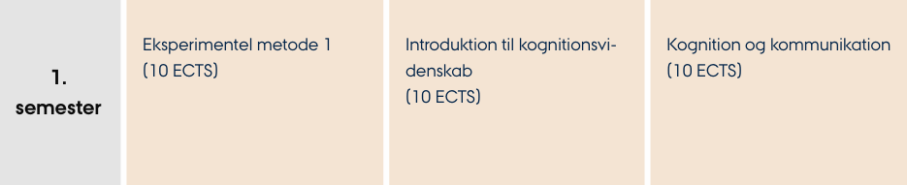

You can learn more about the particular ECTS credits for your courses and about the program structure and general rules from the study regulations (http://bit.ly/2nybqyU). It is necessary to read the regulations as they also tell you about the content of the courses and how to pass exams. Furthermore, you can look up key competencies and descriptions for each of your courses.

### Books

At the beginning of each semester you will have to buy (or borrow) books for the courses. There are several ways to get hold of them – and we will of course help you with it.

Stakbogladen (http://www.stakbogladen.dk/) is an academic bookshop located only a few minutes’ walk from Nobelparken. There you can find many books from various study areas and you can be assisted by some very helpful staff. You can pay with your credit card (Visa, Master Card, Dankort) and get 10% discount as student at Aarhus University.

You can also go online to look for used books. You might find the books on http://www.dba.dk/ or https://www.saxo.com/dk/. You can also go to Amazon.co.uk and find your desired books there.

You might also get the chance to buy books from older students via this google sheet, where you will find contact information on those, who are selling: <http://bit.ly/2pZJzs4>.

You will hear more about which books to buy as soon as you start your education, so don’t worry to much about it for now.

### Study Environment

Student life at Aarhus University is not only filled with lectures, seminars or group works, but also with many extracurricular activities! You can become a member of various kinds of student associations and societies (or you can start your own!), attend one of the many Friday bars at the university or join a sports club. No matter what you decide for, getting involved is always a great idea! You will meet new students, establish friendly relationships with the university teachers and other employees and become a part of the university community.

### faculties, schools and departments

Aarhus University is divided into faculties, schools and departments. The Cognitive Science Bachelor is situated at the department called LICS (Linguistics, Cognitive Science and Semiotics) at the School of Communication and Culture at the faculty of Arts. At the department, there are two local boards called:

UN (UddannelsesNævn) where students, teachers and other university employees make proposals for decisions regarding their relevant studies. In other words, everything that has to do with examinations, lectures or regulations receives a great deal of attention here. Becoming a member, or communicating with already elected students, is a great way of obtaining knowledge about the state of matters and to share your ideas and contribute to important decisions. Furthermore, it is a great way to make contacts at the University, both with teachers and managing department.

Study Board (StudieNævn). The Bachelor in Cognitive Science is one of the studies offered by the School of Communication and Culture (ICC, or IKK). The formal body that makes decisions about the studies at the Institute level is the Study Board, where the UN is represented with two seats, one student and one staff member. Student elections take place in the fall.

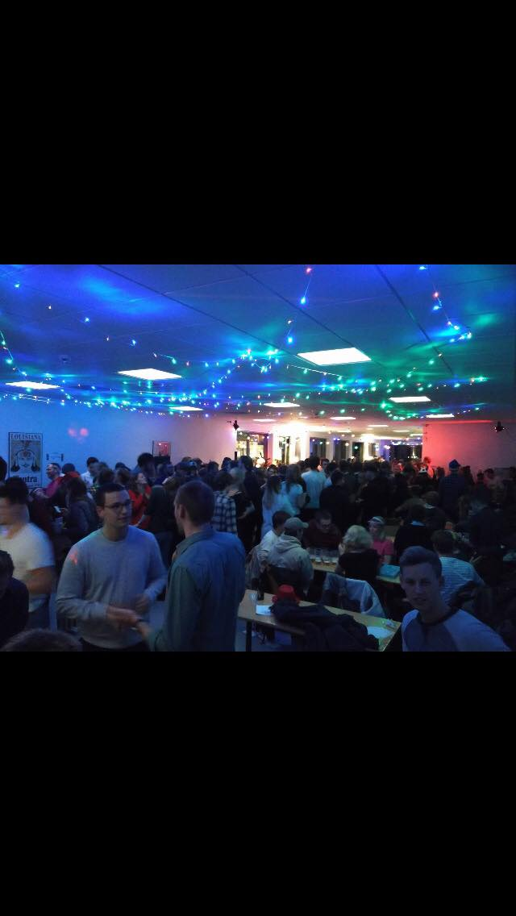

Broca’s Bodega. This is the Friday Bar of Cognitive Science. It is a great place to be if you want to have some fun at the end of a tough long week! You can enjoy a cold cheap beer and have a party with fellow students. The Friday Bar is hosted a couple of Fridays each month, and there will also be theme parties and other events during the semester. The bar is located in building 1483, room number 134 at Nobelparken and we are often joined by students from the rest of Arts and other departments.

You can follow Broca’s Bodega on Facebook: http://bit.ly/2mpTira where they announce future events. During the day, this room can be used as study room.

Study room**.** Room 1483-134 is one of several rooms that during the daytime is available for students to study, read, do class preparations or group meetings. Cognitive Science students will also have their own room for exercises and projects, which is located in 1485-235B. This room also have computers available, and it is often used during classes.

The Neural Network is a newsletter created by students at Cognitive Science at Aarhus University. They send out a newsletter by email once a month, which has information about relevant events and talks, interesting articles, and other tips and information. Once you start your studies, they are also happy to invite you to contribute to the newsletter. The Neural Network also arrange their own events and talks specially designed for students at Cognitive Science, but also open to others. You can sign up to receive the newsletter already: http://bit.ly/2nyaoCR.

You will get more information about various kinds of student associations during the introductory days.



### Cognitive Neuroscience at 2nd semester. An FMRI study conducted by Cognitive Science students!

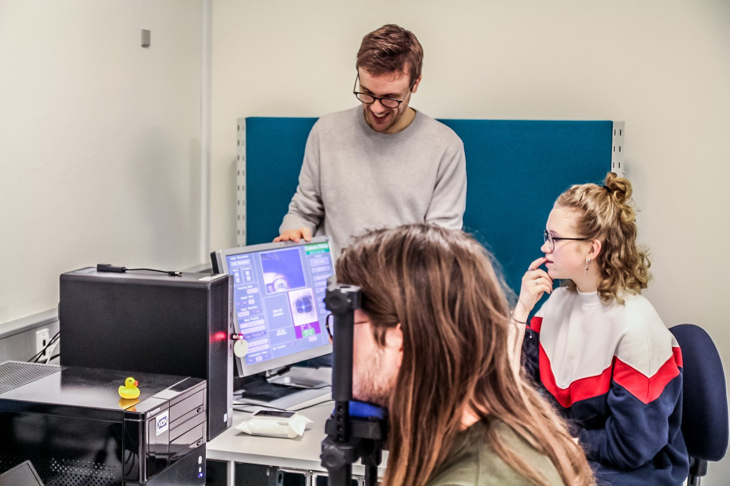

### Eye tracking workshop at 4th semester

# Tips and Tricks

It is normal to be a bit confused about the introduction week, because so many new things are happening. Maybe you just moved to Aarhus and have to get used to living away from your family and friends. Moreover, you have to meet your new study colleagues and get to know the university. Therefore, we put together a little list of tips, tricks and practical information to help you get the best start possible.

### BEFORE THE INTRODUCTION WEEK

1. Download the AU Find-app if you have a smartphone. This will help you to find the right buildings.

2. If you have to use public transport, Rejseplanen (app or webpage) is a really good help to plan your travels by bus and train.

3. Did you remember to apply for SU and boligstøtte? Otherwise, do it!

4. Remember to join the Cognitive Science ‘19 Facebook group.

5. If you live by yourself, remember to clean the apartment, wash your clothes and buy groceries, snacks, toilet paper and shampoo for the entire week. It is very likely that you will not have the time nor the energy to do these things during the introduction week. Check the program for the week, as we will provide breakfast and dinner some of the days. Otherwise, it will be good to bring lunch, if you do not want to buy food in one of the cafeterias at the university.

6. Remember to not make any other plans during the week. It is highly recommended to participate in the full schedule of the introduction week, as this is a perfect chance to get to know your new classmates and make memories for life. Therefore, your work, family and friends will have to wait for another week – you won’t have the time or the energy during the week.

7. Skim the program. Do you have some gym clothes that you do not mind getting wet and dirty? Everyone should go all-in during the introduction week, so be prepared!

8. Be excited! We have an amazing program planned for you, and we are looking forward to meeting you ☺

### DURING THE INTRODUCTION WEEK

1. Come as you are and be yourself. The week is very relaxed, so just wear something comfortable. There will be plenty of opportunities to dress up for the parties!

2. Remember to check the weather forecast and be prepared – we will probably still go through with the fun outside activities even though it is windy and a little rainy.

3. Be open minded. Remember that everyone else is in the same boat as you, so do not be afraid to talk to many new people. You never know who might become your future best friend.

4. Participate in as many activities as possible. You will regret it later if you for example slept in after the pub crawl and missed out on some amazing social activities. We are well aware that there are many things happening and that it might be a bit overwhelming – but we are here to help you and hope to see you for all the activities.

5. However, remember your boundaries and do not pressure yourself too much. Some might party until the middle of the night, but it is perfectly okay not to drink and it is also very understandable if you want to get home early and relax one of the evenings. The introduction week should be fun for everyone ☺

6. Ask the tutors – we are here to help you!

### AFTER THE INTRODUCTION WEEK

1. We will help you buy the books in time, so you do not need to worry about this. The price for the books for the 1st semester will be about 1500 DKK tops, but PDF versions for some of the books might be available for free.

2. You are probably very excited to learn about the brain and the human mind! However, remember that the social aspect of university is very important for your future comfort on the study.

3. Even after the introduction week, you are still very welcome to contact your tutors. We are here to help and give you an amazing start at the university – so do not hesitate to contact us! You can also come over for a beer in the Friday bar!

4. Don’t worry that you will never see us (the tutors) again – we will arrange more events for you after the introduction week!

# SOME HELPFUL LINKS

<https://www.dmi.dk/lokation/show/DK/2624652/Aarhus/> Even though our introduction days take place at the end of summer, the sun in Denmark should not be taken for granted! We will spend a great deal of our afternoon activities outside in the University Park. Remember to check the weather forecast before you leave in the morning.

<http://www.discovercity.dk/> I Discover City is a page where you can find tips and information about great places in Aarhus. Are you in doubt what to do during the weekend? Would you like to explore Aarhus? Would you like to discover a new café or bar? Then use Discover City as your inspiration.

<http://www.au.dk/en/internationalcentre/> **|** The International Center provides services to all

international students and staff. They can help you with housing issues, give you support for your visa or provide you with information about free Danish language education.

<http://kursuskatalog.au.dk/en/> **|** Kursus katalog is a place where to go if you want to learn more about your current or future courses. All you need is to type the name of particular course into the search field.

<http://library.au.dk/> **|** The University library and its resources are accessible via this link. You will get an introduction tour with one of the library employees as part of the introduction program.

<http://library.au.dk/betjeningssteder/nobelparken/> **|** The library at Nobelparken, which you will visit in the Introduction week

<https://www.statsbiblioteket.dk> **|** Another library we will show you.

<https://bibliotek.dk/eng> **|** You can also borrow books from various libraries all over Denmark. You can you use their services after you obtain your Danish CPR number.

<http://laerdansk.dk/> **|** LærDansk is the biggest Danish language network with language centers located in 20 municipalities. You have a wonderful opportunity of learning Danish, make new friends, and establish important connections.

<http://internationalcommunity.dk/> **|** The International community is an expat organization that provides a wide range of events, seminars and online activities.

<http://www.jobindex.dk/english> **|** Finding a job in Denmark is not easy especially if you don’t speak Danish. However, it is not impossible! You can use the JobIndex webpage to get yourself familiar with the Danish job market and explore current offers of student jobs or calls for internships. Remember however that your study is a full-time activity.

## See you in August!